RPC WEBPAGE NEWSLETTER
Volume 12, Issue 2 June 2013

The Imaging and Radiation Oncology Core (IROC) Group

The National Cancer Institute’s (NCI) Cancer Therapy Evaluation Program Clinical Trial program is undergoing a major transformation in response to recommendations from an advisory group from the Institute of Medicine to develop a National Clinical Trial Network (NCTN). This transformation includes going from 10 clinical trial study groups to four adult groups and one pediatric group. Another change will be that the current Radiation Therapy (RT) and Imaging QA centers will also have to combine into one group to administer RT and Imaging core services to the 5 clinical trial groups. To this end, the current leading RT and Imaging Quality Assurance (QA) centers have submitted a joint response to NCI’s FOA to create a single clinical trial QA group known as the Imaging and Radiation Oncology Core Group, or better known as “IROC”. IROC will provide scientific and technical expertise in both diagnostic imaging and radiation oncology to the entire NCTN network. These changes are expected to begin on March 1, 2014.

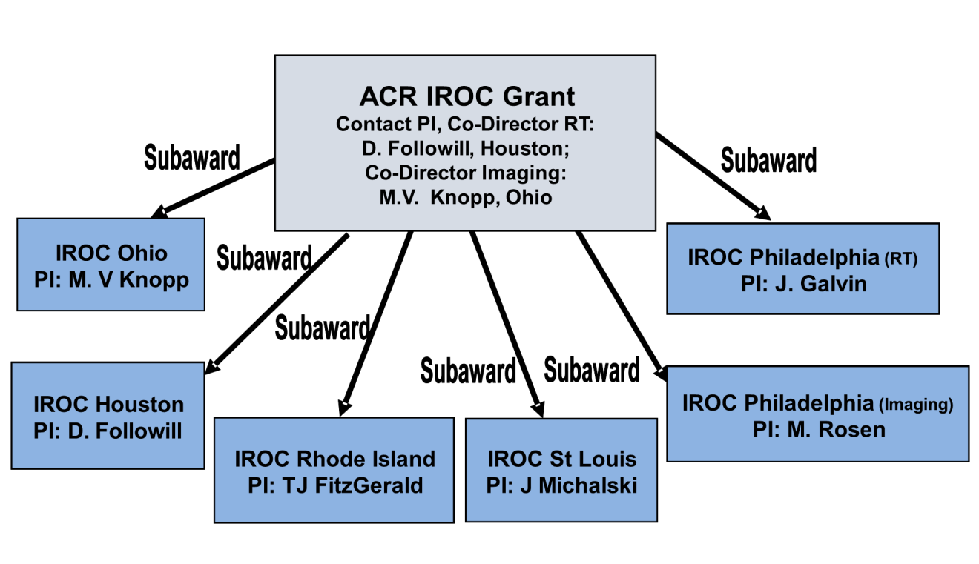IROC will be administratively organized through the American College of Radiology (ACR) Clinical Research Center in Philadelphia with additional centers of support in Houston, TX; Columbus, OH; Lincoln, RI and St Louis as seen in the figure below.

David Followill, Ph.D. and Michael Knopp, M.D. will serve as the initial IROC Co-Directors. The creation of IROC capitalizes on existing infrastructure and expertise at QA centers currently providing services to the NCI Cooperative Groups. Work flows, processes and information systems currently in place will be further enhanced while taking the best practices and standards in an integrated vision across the NCTN.
The interdependencies between diagnostic imaging and radiation oncology will be synergized in this organization eliminating duplication of services within the network and optimizing efficient and effective workflows. A major strength of this new organization will be the development of consistent standard operating procedures for all imaging and radiation oncology aspects of the National Clinical Trial network as well as to facilitate a seamless flow of imaging and RT datasets across the network.

IROC’s organizational structure allows the delivery of a broad array of diagnostic imaging and radiation therapy QA services including Site Qualification; Protocol Consultation and Assistance; Credentialing; Electronic Data Transfer; Protocol Case Review and Management.

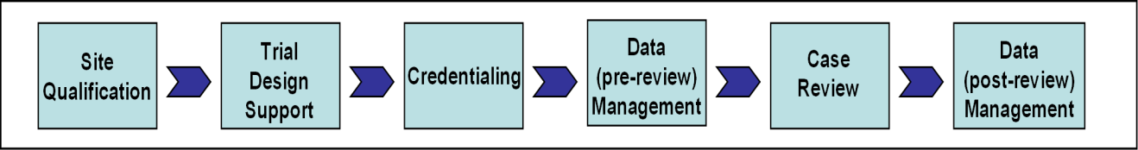
IROC will implement programs that will assure consistent high quality diagnostic imaging and the planning and delivery of high quality radiation therapy across the participating institutions in the NCTN. Policies and standards will be applied uniformly to all of the Network Group Operations Centers. IROC will assure that imaging and RT data used by the Groups for protocol analysis are accurate. IROC leadership will work closely with the leadership of each of the Network Groups and the NCI.IROC membership will interface with the disease and modality committees within each of the Network Groups so that protocol consultation to assure appropriate RT and DI QA measures evolves concurrently with protocol development. Appropriate levels of credentialing and case review will be determined with the Network Group for each protocol. The objectives of the protocol will direct the services that IROC provides.

